Bosley St. Mary’s Primary School
‘Achievement for all in a caring, Christian Community’
5th January 2021
Dear Families,
As a school, we have had to consider the best way to communicate remote learning now we see ourselves in a National Lockdown. We have decided that Google Classroom is the best option as this will allow us to set work and give feedback. Most children in the school have also accessed homework via Google Classroom during the Autumn Term so we are hoping that this platform will be familiar to them and therefore easy to use.
For those families who have yet to access Google Classroom, I hope that the following information will be of some use to you. I have compiled this list of frequently asked questions document to answer any queries you might have around the use of Google Classroom.
Thank you, in advance, for your support and for bearing with us whilst we continue with these developments.
Why are you using Google Classroom?
Google Classroom is an online learning platform that allows teachers to set assignments, give individual feedback and monitor who has completed the work. This platform works well for our school because:
- Google Classroom is an accessible platform that is easy to navigate through.
- Our teachers can continue to work collaboratively with their year group partners, uploading and sharing work-load as they would usually do in school.
- If a member of staff was to become ill, their year group partner would be able to continue to upload, give feedback and provide continuity for the children.
- Google Classroom allows children to work collaboratively on assignments and therefore, continue to learn from and with their peers as they would in school.
How do I access Google Classroom?
- Using your internet browser (Google Chrome will work best for this), go to classroom.google.com.
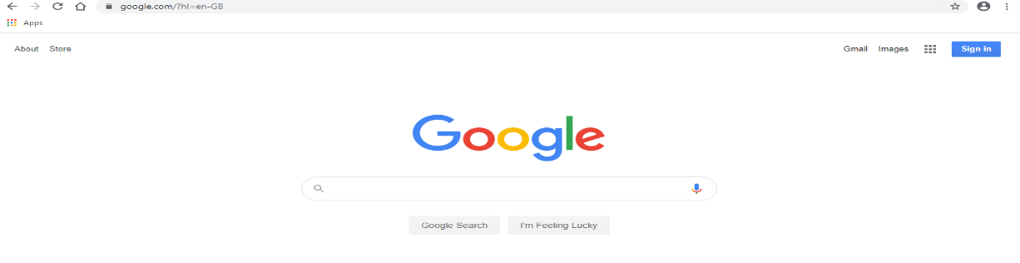

You must be logged on using your child’s email address. If you own is logged, please log out.

Please follow this link for help to access Google Classroom: https://support.google.com/edu/classroom/answer/6072460
Please follow this link for help to join a class with a class code.
https://support.google.com/edu/classroom/answer/6020297
How do I ‘hand in’ assignments to Google Classroom?
It is quite straight forward to ‘hand in’ work that has been completed. Please follow the link below for further help.
https://support.google.com/edu/classroom/answer/6020285?hl=en&ref_topic=9050121
Do I have to do all the work set?
The expectation is that all work set is completed across the week. This can be arranged around your day. If you are struggling to complete the work, please contact your child’s teacher using the class email address.
The recommended study time each day is 3 hours for KS1 children and up to 4 hours for children in KS2.

I don’t have a printer, what can I do?
There is no expectation to print anything off. Just write answers down on paper or discuss the answers with your children. Some children have been provided with home-learning books and some have also been advised to use their homework books or reading journals to record answers.
If my child does not have digital or online access at home, how will you support them to access remote education?
To overcome barriers of digital access we have made available a loan of chrome books to support families to access remote education.
All families have received further information on how to gain access to increasing mobile data using the link below:
https://get-help-with-tech.education.gov.uk/about-increasing-mobile-data
How much work do I send to the teacher?
The expectation is that all work is ‘handed in’, even if there is not an attachment to send back.
How will you assess my child’s work and progress after submitting their work?
We provide written feedback for every piece of work. This is returned to the child via Google Classroom and is in line with how the work would be marked in school. Targets will be provided if the child is not achieving expected standard.
Immediate feedback is given through chatroom comments when undertaking live lessons.

How will you check whether my child is engaging with their work and how will I be informed if there are concerns?
We are able to monitor the activity of what children are accessing via Google Classroom as we view, mark and provide feedback for the children.
We take a daily paper register of children attending the live lessons.
When engagement is a concern, we will contact the parents by phone to discuss how we can best support them and their child.

How will you work with me to help my child who needs additional support from adults at home to access remote education?
We monitor the children’s activity daily and will have contact with parents once a week via phone. Contact with parents whose child needs additional support is more frequent.
Assigned groups of SEN are provided ability appropriate activities on Google Classroom.
We offer a mixture of workbooks, print outs and the use of remote access for children who needs additional support.

Will it just be worksheets posted on Google classroom?
No. We will be providing a variety of activities on Google Classroom.
- Live teaching – the children will receive online lessons daily. Currently, these range from guided reading for KS2, book talk for KS1, foundation subjects such as PE, History, and PSHCE. We also provide three live collective worship sessions.
- recorded teaching – some activities lend themselves to online videos from oak academy or BBC learning. These tend to me uploaded on to Google Classroom as one of our challenges.

Will other children see my child’s work?
Not unless it is a collaboration piece of work. In this instance, all the children will edit the same document so that they can create a bank of ideas that they can all use in future work.
I’m not a teacher, things have changed since I went to school. How do I help?
We do not expect you to take on the role of teacher. These are unprecedented times and the most important thing is that you and your family are well. If an activity is too confusing or you don’t know where to start, please email the teacher and they will be more than happy to provide advice and support.
Whilst the following guidance was for the summer term 2020, it still provides some useful tips that can be applied to a self-isolation or bubble closure period.
https://www.gov.uk/guidance/help-primary-school-children-continue-their-education-during-coronavirus-covid-19
Remember we are here to help, please ask if you need us.
The work is too hard/too easy for my child. What do I do?
Please let your child’s teacher know. They might be able to provide a differentiated activity or they will be able to advise you on where to source other material to support your child.
With increased usage of devices, how can I keep my child safe online?
‘Think U Know’ have released some useful summary guide sheets for parents for both primary and secondary aged children. You will find these at: https://www.thinkuknow.co.uk/professionals/our-views/parents-helpsheets/
They also provide fortnightly online safety Home Activity Packs full of simple, 15 minute activities to support children's online safety.
Will the teachers provide live lessons?
Yes. There will be live lessons for the children to attend throughout the week. We will send a timetable home each Friday which will outline the live lesson schedule for the following week.
How do I join a Google Meet?
If we decide to provide live lessons they will be conducted through Google Meet.
1. Please make sure that your child is free from any distractions e.g. food, pets, siblings.
2. Make sure that you are logged on to the GSuite with your child's login details. It will not let you join if google is logged on with an email address outside our school domain.
3. Open Google Meet. This can be achieved through clicking on the link in your child’s live lesson assignment or through the Google Meet icon next to Google Classroom.
4. Click 'Join or start meeting'
5. Enter the nickname provided by your teacher (case sensitive).
Note that you will not be able to join before the teacher therefore, if you encounter an error message the teacher has not started the meeting. Please try again.
If my child is not in school because they are self-isolating, how will their remote education differ from the approaches described above?
Children who are self-isolating access the same remote provision as all other children. They are also provided feedback in the same way.

And finally…
The success of remote learning requires home and school to work together in a strong partnership. This partnership is something that we are very proud of at Bosley St. Mary’s Primary School. We know that staff and parents are committed to doing their very best to provide continuity of learning for the children during this challenging time. Please get in touch with us via email if you have any issues at all concerning remote learning. We are here to help
We thank you for your patience, support and understanding as we implement this new system.
Stay safe and look after each other.
The Bosley team

