School is a hive of activity and excitement with end of term activities and it feels good to see and hear children enjoying the sunshine and summer events.

Next week promises to be another fun-packed week with lots to look forward to…

Don’t forget:
BosFest (children only) on Wednesday 14th July at 1pm - Children can come to school dressed ready to party if they wish to do so.
Leavers Service (Yr 6 parents only) on Thursday 15th July at 9.30am

Sports Day
Despite the dreary weather, sports day was a huge success. ASM Sport provided us with an array of exciting non-traditional activities such as tyre dragging, weight lifting, tug of war and problem solving team work activities to name but a few. All children did amazingly well and thoroughly enjoyed the day.

BeWILDer @Bosley
There will be no forest school next Wednesday as BosFest will be in full swing!

Transition Days
Not only have our new Reception starters had their first full day with us at Bosley School today, Years 1 and 2 spent the afternoon with Mrs Hadfield yesterday as part of their transition ready for September. Mrs Smith has also been at school this week, spending time planning with Miss Devlin but also getting to know the children in class 2. Mrs Smith will be working with children in year 3, 4 and 5 next Wednesday as part of their transition for next year.

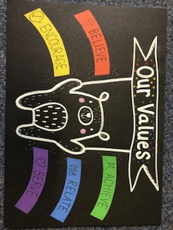
Class 1
ACHIEVE - Ellie - What a super mathematician Ellie has been this week, using numicon to help her count. Well done Ellie.

ACHIEVE - Elise - Elise showed perseverance during a reading quiz this week. She remained positive and achieved a super score. Brilliant work Elise.

Class 2
SERVE - Holly - During sports day Holly noticed that one of her friends needed cheering up. She didn’t hesitate to do the job, with success! What a thoughtful and kind girl you are Holly.
SERVE - Matilda – Matilda is such a kind and caring member of our school community. She is sensitive to others’ feelings and ensures that everyone feels included both in the classroom and on the playground.
Star Reader
Well done to this week’s star readers:
Class 1 - Daniel
Class 2 - Grace
Dates for the diary

July
Fri 9th All Hallows Transition morning
End of year reports sent home
Sat 10th Rose Queen Fete - 2pm – POSTPONED UNTIL SEPTEMBER
Bosley Fell Race
Sun 11th Rose Queen Church Service - POSTPONED UNTIL SEPTEMBER
Weds 14th BosFest
Thur 15th Leavers Service in Church – 9.30am
Fri 16th Summer break

