We have had a busy but enjoyable week…
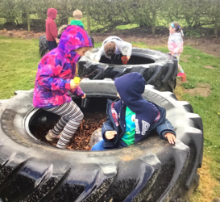
BeWILDer @ Bosley
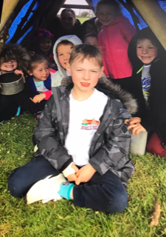
Class 1
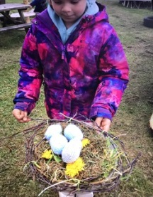
Class 1 continued to think about birds in their BeWILDer session with Mrs Nash. They thought about how birds travel using their wings for change of direction and accuracy. The children made a beak with their fingers and collected small items to make their own nests. All the children had amazing ideas and worked brilliantly as team workers and creative thinkers. The nests were so unique!

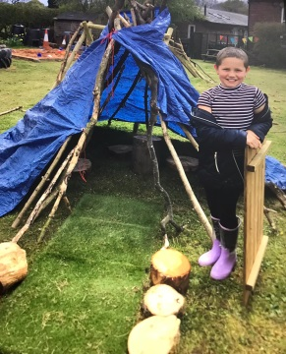
Class 2
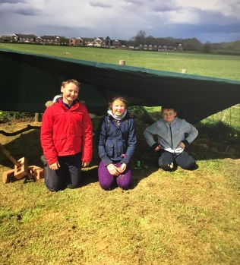
The children in class 2 decided to build dens and shelters to keep dry. They learnt about different types of shelters and started gathering items just as the April showers began! This actually created a wonderful atmosphere of excitement and also purpose! Were the shelters waterproof you ask?! The children soon adapted their shelters to ensure they kept dry! At the end of the session, the children completed a den safari to share ideas with their classmates.

Art and Soul workshop
On Wednesday a special visitor came into school to help us reignite our school Christian Values. Chris Gilbert, also known as The Art and Soul Man, has worked for over 20 years as a secondary school art teacher and also has a wealth of experience in providing Christian children’s work in a variety of school settings. The ethos group met to discuss our values and we decided on the following using the BEARS acronym:

B - Believe
E - Encourage
A - Achieve
R - Relate
S – Serve
The children enjoyed a fun and inspirational assembly from which they discussed symbols they associate with Christianity. From this, the children then took part in decorating posters for a display in the school hall. I think you will agree; the outcome looks fantastic.

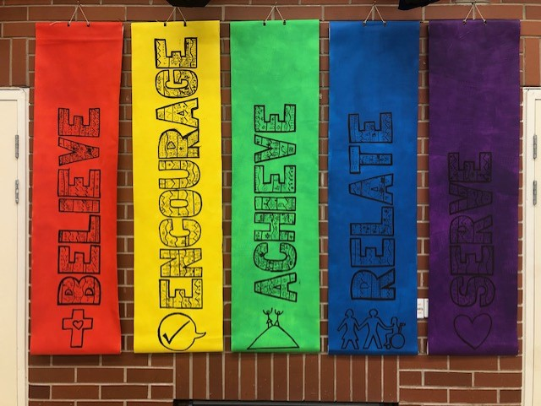

After half term we will be replacing ‘Star of the week’ with our own ‘BEARS Award’. Children who have shown a commitment to one or more of our Christian Values will be praised and awarded with our BEARS certificates in Celebration Assembly.

Sustainability Project
As part of our forest school sessions, Mrs Nash has started work on a new environment challenge encouraging the children to become a 'green-army' to help tackle carbon emissions and climate change. Children can earn their Supersize Green Badge by taking a two-week pledge to change small things in their lives which will make a big difference to the environment. This links beautifully with a sustainability project the children will be taking part in during May and June.

Academy photographs
We were so proud of all the children today as every single child looked super smart in their shirts and ties, brushed hair and big smiles for our class and leavers pictures. We even managed to sneak in a whole school picture too. We can’t wait to see the proofs and will send home order forms as soon as they arrive in school.

BB Club
Thank you for those parents who attended our open afternoon on Wednesday. We are really excited to open the doors to BB Club on Tuesday 4th May. Miss Bown can’t wait to start as BB Club manager and I know she will provide our children with amazing experiences in a caring, supportive environment. More information is now available on the school website under BB Club. Please book in via school spider.
I would just like to say a huge thank you to Mrs Fisher for standing in to run our breakfast club over the past two weeks.

Congratulations, a new starter and a welcome back!
As you know, while Mrs Hadfield has been enjoying baby cuddles at home, Miss Forbes has been covering the teaching of class one in her absence. Alongside teaching class one full time; Miss Forbes has also been busy completing her teacher training. Last week, Miss Forbes and I met with her tutor and I am delighted to announce that she has successfully completed her training with an outstanding grade. Miss Forbes will continue to teach class one up until July. On this note; I would like to take this opportunity to welcome Lewis who will be joining us on Tuesday next week. We’re very excited to welcome Lewis into our Bosley family.
As we congratulate Miss Forbes and welcome Lewis, we also welcome back Mrs Hadfield who will be returning to school on Tuesday 4th May. As Miss Forbes will be continuing to teach in class one, Mrs Hadfield will be joining the teaching team in class two up until July. We are very much looking forward to welcoming Mrs Hadfield back to school.

Stars of the week

Class 1
Ellie – Ellie used her phonics when she completed some independent writing, she really believed in herself and succeeded in producing some super writing.
Hope - Hope achieved her targets by using interesting and exciting vocabulary in her writing.
Class 2
Oscar - Oscar showed commitment when completing his problem solving and reasoning in maths.
Matthew - I was impressed with Matthew’s perseverance with a spelling task he completed this week. Really super effort.

Dates for the diary
May
Mon 3rd School closed for May Day Bank Holiday
Mon 10th Parents Evening
Thurs 27th Last day in school
Fri 28th INSET day

