Tuesday 23rd March was a special day as we came together to mark the anniversary of the first national lockdown. The children were respectful whilst we reflected on the past year. We spoke about remaining optimistic, positive and hopeful and we prayed together for a brighter future.

BeWILDer @ Bosley
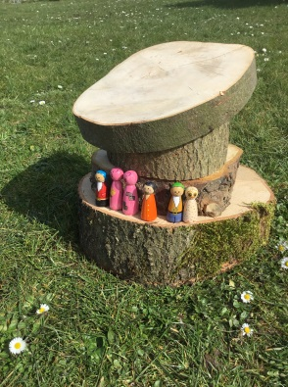
Class 1
The Little People arrived over-night and the children were delighted to meet Owl Babies, The Three Little Pigs and Snow White and the dwarfs.
The children wrote adjectives on a big piece of wallpaper. This then inspired them to complete lots of wonderful independent writing. They wrote where they lived, how they looked and what they ate.
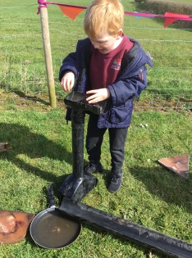
After playtime we then took the Little People to BeWILDer where they the children decided to make their own community. They LOVED making a water park, very creative houses, a prison for a poisonous garden flower and a hospital. Most importantly everyone had lots of fun whilst learning outdoors.
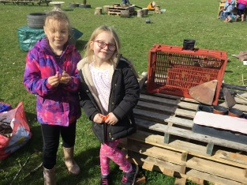
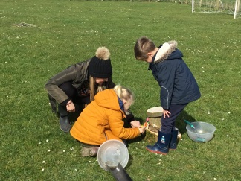
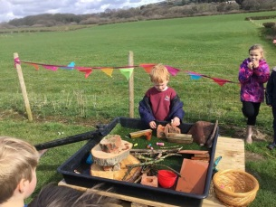
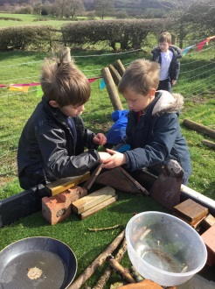

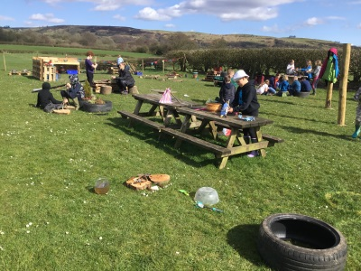
Class 2
Class Two collaborating at BeWILDer. We saw tremendous team work this week; sharing, compromising and supporting one another with a variety of different activities in our forest school session...AND we were blessed with glorious sunshine!
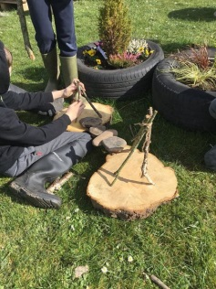
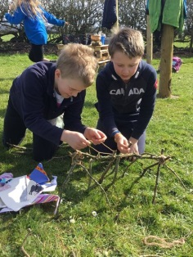
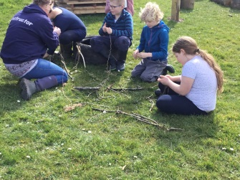
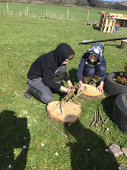
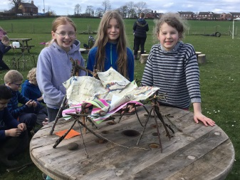

Golden Table
Our Golden Table children have shown superb manners again this week. We are delighted to see how polite and courteous the children are being towards each other and are enjoying each other’s company at lunch time.
Golden Table
Felicity  Toby  Leo  Hope | Helena  Ted  Matilda  Zach

Stars of the week

Class 1
Daniel - Daniel showed off his amazing artistic skills this week. We all agreed that his panda art should be framed! We were also really impressed with Daniel’s independent writing too! Well done!
Charlotte - Charlotte was kind, friendly and welcoming towards our visitor this week. She was such a fantastic ambassador for Bosley School, thank you Charlotte!
Class 2
George - We were so impressed with George’s creativity in English when writing a persuasive leaflet for his endangered animal park.
Joe Lee - Joe has such a fantastic work ethic and always completes his work with such great effort and enthusiasm-well done!

Activities next week:
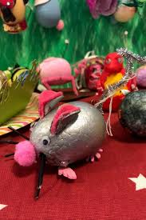
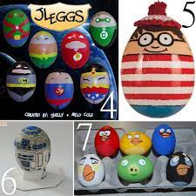
We will be organising a few events next week for the children to enjoy before we break up for the Easter holidays.
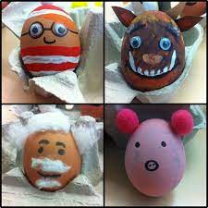
Tuesday 30 March^{th} - Best dressed egg - Please hard boil an egg and decorate it/transform it into a character of your choice.
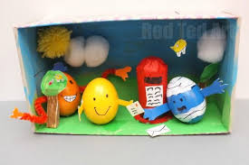
The school council will then decide on a winner from class one and a winner from class two.

Colouring competition – The PTA have organised a colouring competition which we will complete in school. There will be a prize for class one and a prize for class two.

Dates for the diary

April
Thur 1st School closes for Easter
Mon 19th School reopens for the children
May
Mon 10th Parents Evening
* WE WILL KEEP YOU UPDATED WITH ALL ADDITIONAL DATES OR ANY CHANGES AS THE TERM PROGRESSES.

