We are all continuing to enjoy being back together in school. The children are working incredibly hard; their enthusiasm for learning is still very infectious.

BeWILDer @ Bosley

Class 1 had an amazing time in BeWILDer this week, they worked hard on their outdoor maths before play and after play they designed and made their own dens for the secret visitors that appeared in the playground.
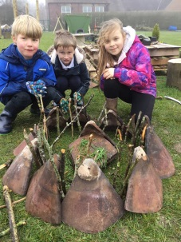
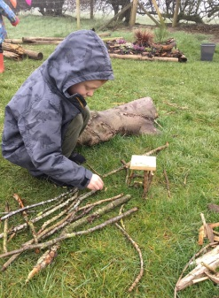
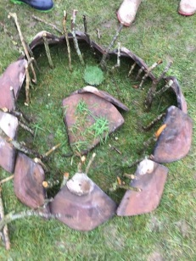
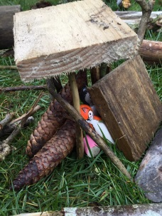
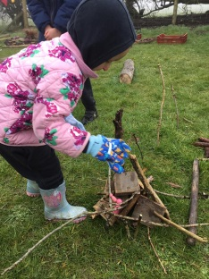
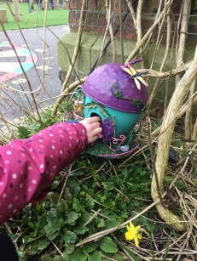

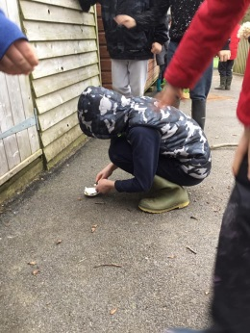
Class 2 investigated the elements that make up the fire triangle. They each made their own mini shell fires with flint and steel (a little helping hand!) and were even treated to marshmallows around the fire pit!

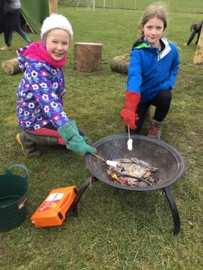
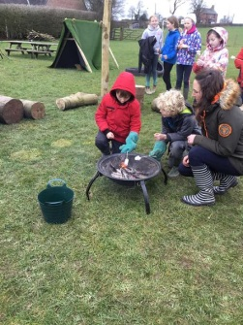
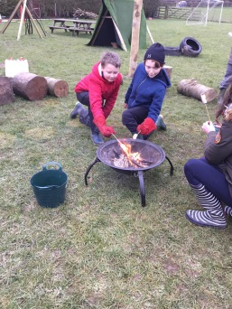
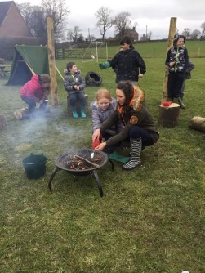

KS1 – Thursday morning. Please send PE kits in a named plastic bag so the children can get changed after forest school for their afternoon PE session.
KS2 – Thursday afternoon. Children can come to school dressed in their forest school clothing but in the event of the weather taking a turn for the worse, please send a spare set of clothing in a named plastic bag.

After School Sports Clubs - PLEASE ENSURE YOU BOOK VIA SCHOOL SPIDER
Our after school sports clubs will continue next week:
Monday - Multi-skills
Tuesday - Dodgeball
Thursday - Football Skills

Golden Table
Our Golden Table children have shown superb manners this week. We are delighted to see how polite and courteous the children are being towards each other and are enjoying each other’s company at lunch time.
Golden Table
Harry  Charlotte  Isaac  Daniel | Joe Little  Gracie-Lilly  Joe Lee  Faye

Stars of the week

Isaac - Isaac has shown great determination for wanting to achieve his potential this week. He has had such a positive growth mindset!
Zach – Zach has proved he CAN do it! He has shown a real commitment to his learning and has worked hard all week.

Today we have supported Red Nose Day in school with
children being invited to wear a red item of clothing or a red nose day product. It was lovely to see so many children
participating and supporting such a worthy cause.
I’m thrilled to say we raised £50…thank you to you all for supporting such a worthy cause.

National Day of Reflection
On Tuesday 23rd March we will be marking 1 year since the start of the first lockdown. At 12 noon, our school will hold a period of 1 minutes silence to mark the occasion. This will be followed by a short prayer and reflection to remember those who have died, to pray for those who care for others, to pray for all who are in need and to share our hopes for the future.

Dates for the diary

March
Tues 23rd National Day of Reflection
April
Thur 1st School closes for Easter
Mon 19th School reopens for the children
May
Mon 10th Parents Evening
* WE WILL KEEP YOU UPDATED WITH ALL ADDITIONAL DATES OR ANY CHANGES AS THE TERM PROGRESSES.

